Zeus #5731
Monday, March 16, 2020
11:30 AM

Zeus
Asteroid 5731, Zeus, is an Apollo asteroid discovered on November 4, 1988 by Carolyn S. Shoemaker at Palomar Observatory near Pauma Valley, California. It has a period of 3 years, 147 days.
It was named for the Greek supreme god, Zeus, Lord of the Sky, who the Romans called Jupiter.

Astrologically, asteroid Zeus has been linked to explosions, fire, penetration, good aim.

From <http://markandrewholmes.com/zeus.html>

Zeus (zoos)
Keywords: Controlled, directed energy. Machines; creativity; leadership. All things military. Combustion engines. Compulsion. Drive.

From <http://junojuno2.tripod.com/tnps.htm>

ZEUS Directed energy, targets and goals, ambition, creation

ZEUS: The spark, the spring. Creation and productivity. Heat, fire. Fighting: military and interpersonal

From <http://midpointobservatory.blogspot.com/2007/12/keywords.html>

ZEUS
Strong forces and power: weapons, anger, will power, machines, fuel, fire, targets, the military, conception, creativity, drive, obsessions, purposeful actions. Zeus represents control and restraint, but when badly afflicted can also indicate loss of control. Excitement, incitement.

From <http://straightwoo.com/2016/06/26/the-hypothetical-trans-neptunian-planets/>

Zeus: Zeus is the most mechanical of the Transneptunians, representing military themes, such as will, determination, and taking orders. As the second part of the “soul cycle,” it marks the place where we learn to submit to authority, follow the rules, and understand the responsibility of free will. Zeus is a subconsciously inspirational force in Uranian astrology.
(Related tropical planets: Mars and Saturn)

From <https://astral-obscura.tumblr.com/post/142857341058/uranian-astrology-the-hypothetical-planets>

Zeus
Asteroid 5731, Zeus, is an Apollo asteroid discovered on November 4, 1988 by Carolyn S. Shoemaker at Palomar Observatory near Pauma Valley, California. It has a period of 3 years, 147 days.
It was named for the Greek supreme god, Zeus, Lord of the Sky, who the Romans called Jupiter.
Astrologically, asteroid Zeus has been linked to explosions, fire, penetration, good aim.

From <http://markandrewholmes.com/zeus.html>

Zeus (zoos)
Keywords: Controlled, directed energy. Machines; creativity; leadership. All things military. Combustion engines. Compulsion. Drive.
A symbol of "controlled energy," Zeus is linked to all types of creative and procreative endeavors. It has an active, fiery nature, and lends considerable zest and drive to whatever it touches. Machinery, weapons, and the combustion engine are all related to Zeus, as are production lines and leadership activities.
In combination with Kronos and Vulcanus, Zeus has been found to have strong ties to the weapons and destructive power of modern warfare, and all three planets were closely linked throughout the entire period of World War II. Zeus (16 degrees Leo) squared Kronos (16 degrees Taurus) at the start of the war (September 1, 1939), and (at 18 degrees Leo) was exactly sextile Vulcanus (18 degrees Gemini) during the bombing of Pearl Harbor (December 7, 1941). But Zeus's creative energy and focused drive normally finds more positive, less destructive, outlets in the natal chart -- through sports activities, for example. Professional football quarterback Joe Namuth has his natal Zeus (18 degrees Leo) sesquiquadrate natal Mars (3 degrees Aries), while jockey Robyn Smith as her natal Zeus (20 degrees Leo) semi-sextile natal Mars (20 degrees Virgo) and conjunct her natal Sun (21 degrees Leo).

From <https://www.astrologysoftware.com/resources/articles/uranian.asp>

ZEUS

Creation
War, dispute, with or without weapons (martial arts)

From <http://midpointobservatory.blogspot.com/2007/12/keywords.html>

Where we find planetary Zeus in a chart is where we find channeled and directed creative energies. It's a recipe for leadership, achievement and positive goals of all types.
In Greek mythology, Zeus was that guy who was able to use his ambition, creativity and intelligence to convince everyone around him that he is the one who should be leading, and so he was able to build alliances and momentum in this way. He knew how to treat people and because of that he easily maintained his power.
Zeus is symbolized by what appears to be a lightning bolt or a phoenix rising from the ashes with its four converging, open bottomed triangles and ascending arrow. It is also a symbol of fertility.

Zeus in Astrology. The planet of channeled, directed and creative energies.

From <http://theuranianastrologer.com/zeus>

The Greeks often put faces on the forces that shaped the world and the natural world was very frightening to them so they associated it with the divine. In Greek mythology Zeus was the most feared but also the most respected of all the gods. He had command of the skies and that gave him the most deadly weapon which was lightning. So when natural catastrophes happened people believed they were sent by Zeus. He was a true leader and a bringer of order, justice and civilization.
Zeus was that guy who was able to use his ambition, his creativity, and his intelligence to convince everyone around him that he was the one who should be leading, so he was able to build alliances and momentum in this way. He knew how to treat people and because of that he easily maintained his power.

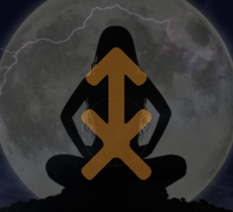
What we can also see from the astrological symbol of Zeus is virility and fertility as you get somewhat of a phallic symbol. Both Freud and Jung saw lightning as a phallic symbol and Zeus was known to have an incredible sex drive. He sought many women and it is thought that he had hundreds of children, a child with every woman he was ever with. So the Greeks wanted to be connected with this virility, fertility, power, and they were pretty proud if there was someone in their village who was a child of Zeus’s. His offspring is often what produced their local ruling families.
So where we find Zeus in a chart is where we find controlled, directed and creative energies. It’s a recipe for leadership, achievement and positive goals of all types. So let's take a look at the charts of individuals with some strong Zeus energy.

Prince William
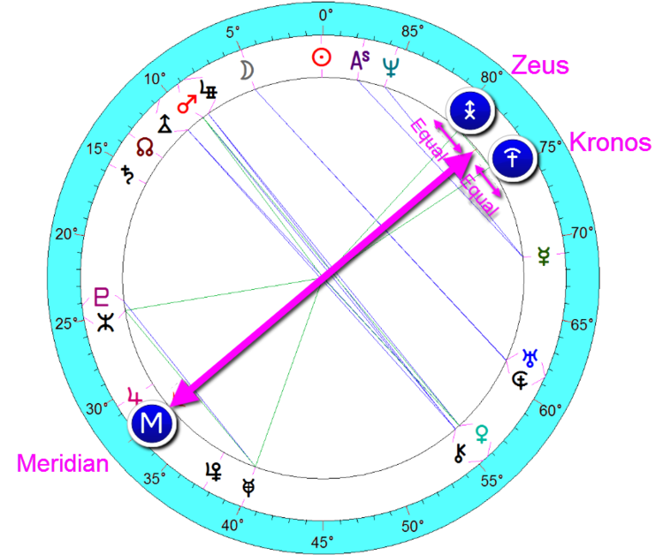
PRINCE WILLIAM - JUNE 21, 1982 @ 9:03 PM PADDINGTON, ENGLAND
First up, Prince William. Now when we take a look around the Meridian of Prince William’s chart, (and remember the Meridian is like a snapshot of the soul, it is the point of individuality, what we really want regardless of whether it brings attention and recognition from the outside) we have a very interesting midpoint structure here of Zeus and Kronos. So of course Zeus is all about leadership, direction, the urge to activate, and Kronos is all about things high up, literally and figuratively. Kronos deals with governments, bureaucracies, leadership positions, official positions, distinguished societies, the social elite, integrity, or things that are about average or excellent, someone who is outstanding at a particular thing. So when Zeus/Kronos get together as they do in Prince William’s chart, it’s the combination of a “commander in chief,” someone with a strong personality who wants to be an authority figure. Now you may think wait a minute, he seems so sensitive and mild? Well don’t forget he does have the Sun and the Moon both in the sign of Cancer, a water sign, so there’s plenty of sensitivity to this man with strong needs around belonging. But the Meridian is powerfully placed in the sign of Scorpio, and blended with the Zeus/Kronos midpoint, this gives him a lot of lofty and fiery directed energy. This is someone who would very much like to lead and would be a fine leader at that.
Now the kicker to this whole Zeus/Kronos structure with the Meridian is the fact that it makes a 3-point picture with Jupiter (see below). The planet Jupiter expands whatever it touches with faith, optimism, positive growth and development, and it’s within 2 degrees of that Scorpio Meridian. So with the Jupiter being a part of that 3 point picture with the Zeus and Kronos you can absolutely see that he would make a very fine leader because he’s got the power, he wants to direct it, and with all of that water you have a very sensitive and caring man.
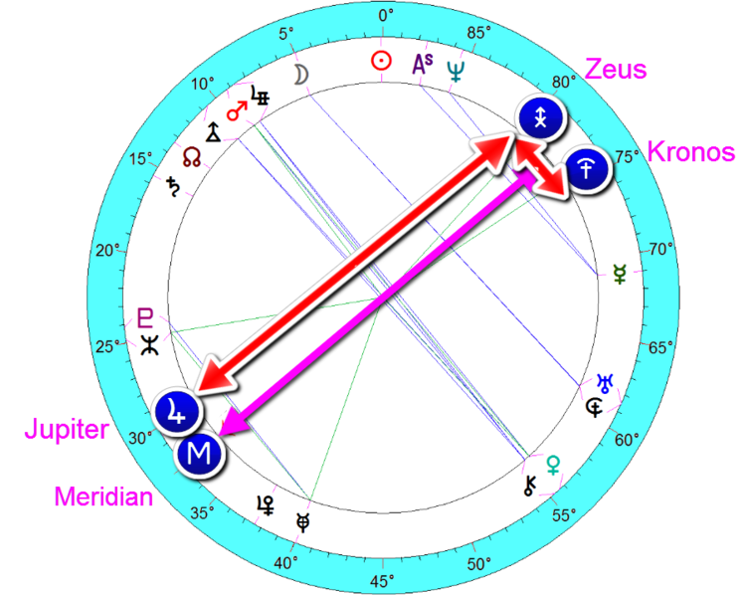
PRINCE WILLIAM - JUPITER/ZEUS/KRONOS 3 POINT PICTURE AROUND THE MERIDIAN

Barack Obama
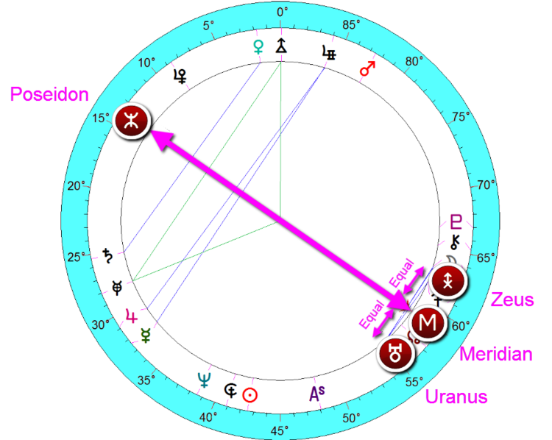
BARACK OBAMA ~ AUGUST 4, 1961 @ 7:24 PM HONOLULU, HAWAII
Next up we have the chart of Barack Obama. He too, like Prince William, has that powerfully intense Scorpio Meridian and around that Scorpio Meridian we have a Zeus/Uranus midpoint structure. Again, our Zeus with its directed, creative leadership energy, blends here with Uranus, the planet of reformers, inventors, technicians. Uranus is the planet of individuality and personal freedom. It wants to do what it wants, when it wants, how it wants, it doesn’t want to be told what to do, and it wants to express the part of the self that is different, not like others. And if Uranus is supported by the rest of the chart it can be exceptionally visionary, using its energy for reform, revolution, and change. So with the Uranus/Zeus midpoint structure on its own and around the Meridian you have a leader with a lot of willfulness, a lot of energetic willpower, it’s a very independent situation and necessary for someone who is in that type of position.
Now here is where it gets interesting because the Zeus/Uranus midpoint also hooks in with the planet Poseidon, which aligns perfectly with his Meridian. Poseidon has to do with the higher mind, truth, insight and consciousness. Poseidon absorbs, is incredibly receptive, but then wants to illuminate out in the form of insight and wisdom, shining the light on something and a desire to operate from an idealistic viewpoint. So with a Meridian/Poseidon midpoint on its own, we have someone who is quite insightful and visionary, and combined with that willful leadership of Uranus/Zeus you get someone who wants to use their power to illuminate their idealistic visions.
Also on the Meridian axis is a Mercury/Apollon midpoint structure (not highlighted). Apollon has an expansive effect on Mercury and illuminates someone who is open minded, enjoys communicating, has business acumen and many ideas. So with Mercury/Apollon blended with the Uranus/Zeus and the Poseidon around the Meridian axis, we get someone who has the potential to be a powerful orator. We got our first glimpse of this in his speech at the 2004 Democratic convention where he captivated and inspired many, setting himself on the journey to POTUS. Now despite his unpopularity as a President at the moment, I really do think he’ll be much more successful out of office, more like a Jimmy Carter, as a visionary or inspirational figure.

Bruce Lee

BRUCE LEE
Now we come to the chart of Bruce Lee. Here we are going to take a look at Zeus in relation to the physical and virility. Bruce Lee was widely considered the father of mixed martial arts. He was essentially an action hero, a film actor and film maker who was a real pop culture icon of the 20th century. He developed his own techniques and was known for his almost obsessive training, training, fitness and nutrition regimens to become as strong as could.

So here instead of going to the Meridian we are going to go to the planetary symbol that represents physical body which is the Sun (see chart below). Now around the Sun we get a Meridian/Zeus midpoint structure. So wherever we find the Meridian in a midpoint structure in terms of the ease of understanding we can substitute the “my.” In this case Meridian/Zeus, my direction, my leadership, my force, my virility. Meridian/Zeus gives an urge to accomplish a great deal physically when positioned around the symbol of the physical body, and if supported and not too hindered by other aspects is the structure of a true sportsman.
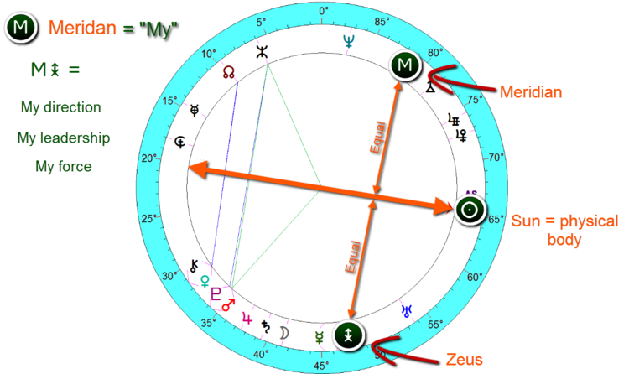
BRUCE LEE ~ NOVEMBER 27, 1940 @ 7:12 AM SAN FRANCISCO, CALIFORNIA
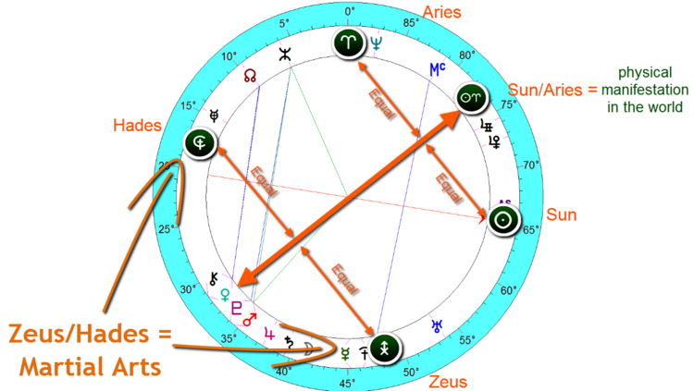
So what’s so great about the Uranian system of astrology is that there are many different ways to find information that you may be looking for. If we wanted more information that pertains to Lee’s physical body we can also try looking at the Sun/Aries midpoint structure (see chart above). Again, the Sun being the physical body, and the Aries point (or Cardinal axis) represents the world or more specifically Bruce Lee’s physical manifestation in the world. So around this point we have a Zeus/Hades midpoint structure. Now Hades often drags whatever it touches into the underworld, but positively manifested Hades represents the antiquities. So this creative, virile energy manifests in the world of Martial arts (positive Hades energy - the antiquities), and it ties into Venus/Vulcanus as well which is someone who is powerfully attractive (and showy) in this area. Think about Venus which is beauty and love, and Vulcanus which is an explosive energy like a Volcano. This is someone who really had the power and charisma to transform the world of Martial arts as well as the way that all Asians were represented in foreign films.

From <http://theuranianastrologer.com/zeus>

PSYCHOLOGICAL UNDERPINNINGS OF ZEUS

Leader.
A feeling of destiny, a reason for being alive.
Goal achiever.
Visonary or fanatic or zealot with a cause (right or wrong).
A person who is willing to be assertive and aggressive, if need be, to achieve their goal/dream/vision.
Over-achiever.
Type A behavior.
A "doer" ("lead, follow or get the hell out of the way" mentality).
Military career person or was in the military.
Highly creative; a writer, artist or someone who has "brain children."
Children/baby oriented; wants a big family. Dotes on children.
A teacher of children; kindergarten, grade school-- good with children and bringing out their creativity and inspiring them toward confidence and self-esteem.
May be sexually promiscuous; extra-marital affair(s).
If a woman, an "Amazon" stereotype.
Warriors by nature (man or woman); they are not peaceable or do they necessarily believe peace and diplomacy will bring about results. They believe action/war/attacking/assaulting/charging it will do it better/quicker/faster in their mindset.
Brave, courageous and foolhardy; a good person to have around in an emergency because they are thinking (usually).
Vocations will involve leadership in some area; be it the military, the government (secret service, FBI, etc.), corporate raider, owner of their own business, marketing, advertising, sales, and into the "arts" and culture, especially painting, drawing, etc.
Confident-- sometimes, too much so if their Ego is not in balance with the rest of them.
Egotistical.
Narsicistic; "me first, last and always" attitude.
Doesn't suffer fools gladly.
Their reality is seeing the world in a new way, a new, improved vision which they feel they can help facilitate and bring about.
A strong sense of "right" and "wrong"-- sees things too black and white and refuses to acknowledge the "gray areas" of life or people's actions/reactions.
Rigid and inflexible in their opinions and how they see life. "My way is the right way" kind of mindset.
Aristocratic; may feel they should be treated like "royalty" because of who they are, the money/fame/power they have accrued.
Classism; prejudice toward those who are "lower" in station than s/he is.
Arrogance.
A sense of duty and responsibility to those they love or employ.
Highly motivated; excellent in sales and sales talks in motivating others. A "hard charger."
Athletic, highly active, loves to work out at a gym, and wants to be out of doors and into Nature.
Hates offices; wants to work or be outside-- forest ranger, fire fighter or any job "where the action is."
Strong Zeus in chart, the person moves every 5 years or changes jobs every 5 years.
A "driven" person.
Highly competent and has the ability to organize on a grand or global scale.
A versitile, creative person who can work within an organization OR strike out on their own. Creative business owner and entrepeneur.
Good parents (or has the capability to become one); the child's needs come first, not second.
Love affairs may abound.
Willful. May become aggressively willful to fulfill their vision/goal.

From <http://junojuno2.tripod.com/zeus2.htm>

Hypothetical Planets, sometimes called hidden planets are a more obscure aspect of astrology. In real astronomy these are actual hypothetical planets that have not been proven to exist or not exist.
Zeus rules over creativity, drive, sometimes aggression, impulse, and leadership. Today I am concentrating on creativity. Zeus changes zodiac sign every 40 years. But it is sensitive to degrees which help identify the differences in each persons chart.
Since sometime in the late 1950’s, possibly 1960 to 1993 Zeus has been in Virgo. It is currently in Libra. Before Virgo was Leo.
Zeus in Virgo channels its creative energy through hard work, organization, and skill building. These people may have build up their expertise through learning, practice, and patience rather than pure talent. They are associated with certain degrees getting caught in lazy patterns and self-criticism which hurt their creative self. They can easily become distracted and scattered from their goals and talents.
Zeus in Libra is a group that finds networking and social presence to be more helpful in obtaining goals and showing their talents.They might find they are naturally gifted but they need connections to get a foot up in showcasing their work. They can find that jealousy, over confidence, selfishness, and competitiveness will block their creative growth.
Zeus in Leo took a great deal of pride in their creative work. Likely only those who were extremely gifted became noticed. Their creative energy can be hard to block and is usually only done so through external powers and authority. Certain degrees could indicate a lack of creative motivation due to issues in low self-esteem.

From <https://theastronymph.tumblr.com/post/154779077595/the-hypothetical-planet-zeus>

Where we find planetary Zeus in a chart is where we find channeled and directed creative energies. It's a recipe for leadership, achievement and positive goals of all types.
In Greek mythology, Zeus was that guy who was able to use his ambition, creativity and intelligence to convince everyone around him that he is the one who should be leading, and so he was able to build alliances and momentum in this way. He knew how to treat people and because of that he easily maintained his power.
Zeus is symbolized by what appears to be a lightning bolt or a phoenix rising from the ashes with its four converging, open bottomed triangles and ascending arrow. It is also a symbol of fertility.

Zeus in Astrology. The planet of channeled, directed and creative energies.

From <http://theuranianastrologer.com/zeus>

The Greeks often put faces on the forces that shaped the world and the natural world was very frightening to them so they associated it with the divine. In Greek mythology Zeus was the most feared but also the most respected of all the gods. He had command of the skies and that gave him the most deadly weapon which was lightning. So when natural catastrophes happened people believed they were sent by Zeus. He was a true leader and a bringer of order, justice and civilization.
Zeus was that guy who was able to use his ambition, his creativity, and his intelligence to convince everyone around him that he was the one who should be leading, so he was able to build alliances and momentum in this way. He knew how to treat people and because of that he easily maintained his power.

What we can also see from the astrological symbol of Zeus is virility and fertility as you get somewhat of a phallic symbol. Both Freud and Jung saw lightning as a phallic symbol and Zeus was known to have an incredible sex drive. He sought many women and it is thought that he had hundreds of children, a child with every woman he was ever with. So the Greeks wanted to be connected with this virility, fertility, power, and they were pretty proud if there was someone in their village who was a child of Zeus’s. His offspring is often what produced their local ruling families.
So where we find Zeus in a chart is where we find controlled, directed and creative energies. It’s a recipe for leadership, achievement and positive goals of all types. So let's take a look at the charts of individuals with some strong Zeus energy.

Prince William

PRINCE WILLIAM - JUNE 21, 1982 @ 9:03 PM PADDINGTON, ENGLAND
First up, Prince William. Now when we take a look around the Meridian of Prince William’s chart, (and remember the Meridian is like a snapshot of the soul, it is the point of individuality, what we really want regardless of whether it brings attention and recognition from the outside) we have a very interesting midpoint structure here of Zeus and Kronos. So of course Zeus is all about leadership, direction, the urge to activate, and Kronos is all about things high up, literally and figuratively. Kronos deals with governments, bureaucracies, leadership positions, official positions, distinguished societies, the social elite, integrity, or things that are about average or excellent, someone who is outstanding at a particular thing. So when Zeus/Kronos get together as they do in Prince William’s chart, it’s the combination of a “commander in chief,” someone with a strong personality who wants to be an authority figure. Now you may think wait a minute, he seems so sensitive and mild? Well don’t forget he does have the Sun and the Moon both in the sign of Cancer, a water sign, so there’s plenty of sensitivity to this man with strong needs around belonging. But the Meridian is powerfully placed in the sign of Scorpio, and blended with the Zeus/Kronos midpoint, this gives him a lot of lofty and fiery directed energy. This is someone who would very much like to lead and would be a fine leader at that.
Now the kicker to this whole Zeus/Kronos structure with the Meridian is the fact that it makes a 3-point picture with Jupiter (see below). The planet Jupiter expands whatever it touches with faith, optimism, positive growth and development, and it’s within 2 degrees of that Scorpio Meridian. So with the Jupiter being a part of that 3 point picture with the Zeus and Kronos you can absolutely see that he would make a very fine leader because he’s got the power, he wants to direct it, and with all of that water you have a very sensitive and caring man.

PRINCE WILLIAM - JUPITER/ZEUS/KRONOS 3 POINT PICTURE AROUND THE MERIDIAN

Barack Obama

BARACK OBAMA ~ AUGUST 4, 1961 @ 7:24 PM HONOLULU, HAWAII
Next up we have the chart of Barack Obama. He too, like Prince William, has that powerfully intense Scorpio Meridian and around that Scorpio Meridian we have a Zeus/Uranus midpoint structure. Again, our Zeus with its directed, creative leadership energy, blends here with Uranus, the planet of reformers, inventors, technicians. Uranus is the planet of individuality and personal freedom. It wants to do what it wants, when it wants, how it wants, it doesn’t want to be told what to do, and it wants to express the part of the self that is different, not like others. And if Uranus is supported by the rest of the chart it can be exceptionally visionary, using its energy for reform, revolution, and change. So with the Uranus/Zeus midpoint structure on its own and around the Meridian you have a leader with a lot of willfulness, a lot of energetic willpower, it’s a very independent situation and necessary for someone who is in that type of position.
Now here is where it gets interesting because the Zeus/Uranus midpoint also hooks in with the planet Poseidon, which aligns perfectly with his Meridian. Poseidon has to do with the higher mind, truth, insight and consciousness. Poseidon absorbs, is incredibly receptive, but then wants to illuminate out in the form of insight and wisdom, shining the light on something and a desire to operate from an idealistic viewpoint. So with a Meridian/Poseidon midpoint on its own, we have someone who is quite insightful and visionary, and combined with that willful leadership of Uranus/Zeus you get someone who wants to use their power to illuminate their idealistic visions.
Also on the Meridian axis is a Mercury/Apollon midpoint structure (not highlighted). Apollon has an expansive effect on Mercury and illuminates someone who is open minded, enjoys communicating, has business acumen and many ideas. So with Mercury/Apollon blended with the Uranus/Zeus and the Poseidon around the Meridian axis, we get someone who has the potential to be a powerful orator. We got our first glimpse of this in his speech at the 2004 Democratic convention where he captivated and inspired many, setting himself on the journey to POTUS. Now despite his unpopularity as a President at the moment, I really do think he’ll be much more successful out of office, more like a Jimmy Carter, as a visionary or inspirational figure.

The Hypothetical Planet Zeus
Hypothetical Planets, sometimes called hidden planets are a more obscure aspect of astrology. In real astronomy these are actual hypothetical planets that have not been proven to exist or not exist.
Zeus rules over creativity, drive, sometimes aggression, impulse, and leadership. Today I am concentrating on creativity. Zeus changes zodiac sign every 40 years. But it is sensitive to degrees which help identify the differences in each persons chart.
Since sometime in the late 1950's, possibly 1960 to 1993 Zeus has been in Virgo. It is currently in Libra. Before Virgo was Leo.
Zeus in Virgo channels its creative energy through hard work, organization, and skill building. These people may have build up their expertise through learning, practice, and patience rather than pure talent. They are associated with certain degrees getting caught in lazy patterns and self-criticism which hurt their creative self. They can easily become distracted and scattered from their goals and talents.
Zeus in Libra is a group that finds networking and social presence to be more helpful in obtaining goals and showing their talents.They might find they are naturally gifted but they need connections to get a foot up in showcasing their work. They can find that jealousy, over confidence, selfishness, and competitiveness will block their creative growth.
Zeus in Leo took a great deal of pride in their creative work. Likely only those who were extremely gifted became noticed. Their creative energy can be hard to block and is usually only done so through external powers and authority. Certain degrees could indicate a lack of creative motivation due to issues in low self-esteem.

From <https://www.tumblr.com/search/hypothetical+planets>

ZEUS: Restrained or creative fire/energy; enthusiasm; controlled & directed forces (thus both planning and controlling strong emotions;) guns, power tools, machines, motors, fireplaces, fuels; excitement; to incite; military; blood pressure; ability to harness energies for accomplishment.

From <https://themercurialdevils.tumblr.com/page/2>

